Test 1: Successful registration:
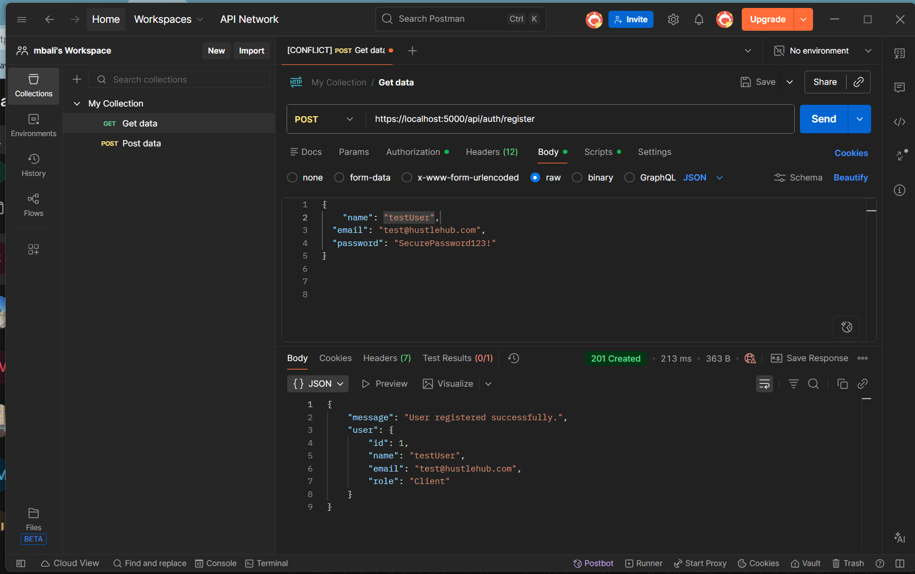

Test 2: Unsuccessful registration (missing name):
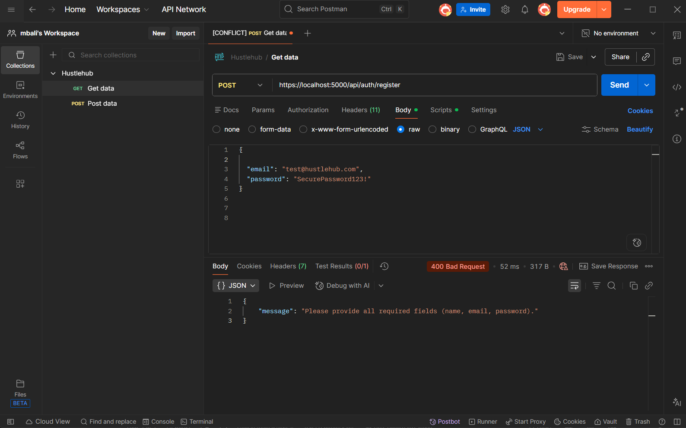

Test 3: Unsuccessful registration (Incorrect password format):
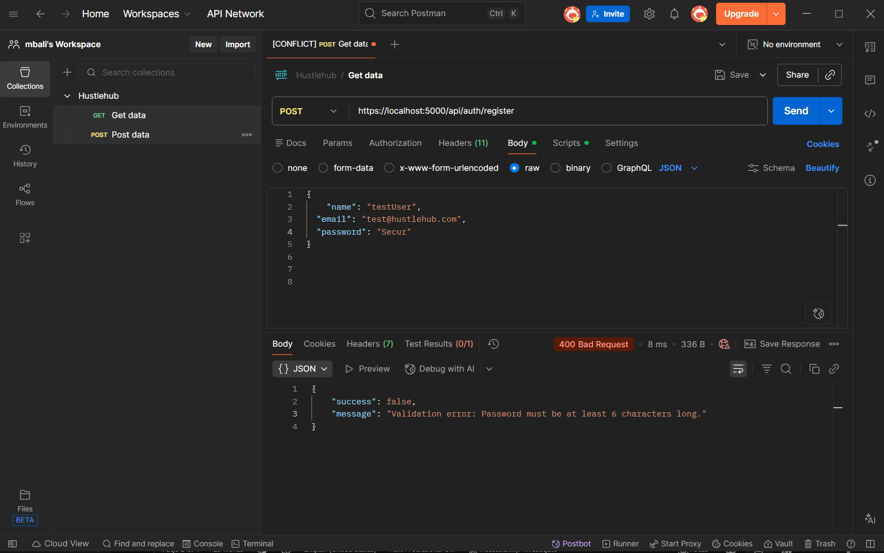

Test 3: Unsuccessful registration (Incorrect email format):
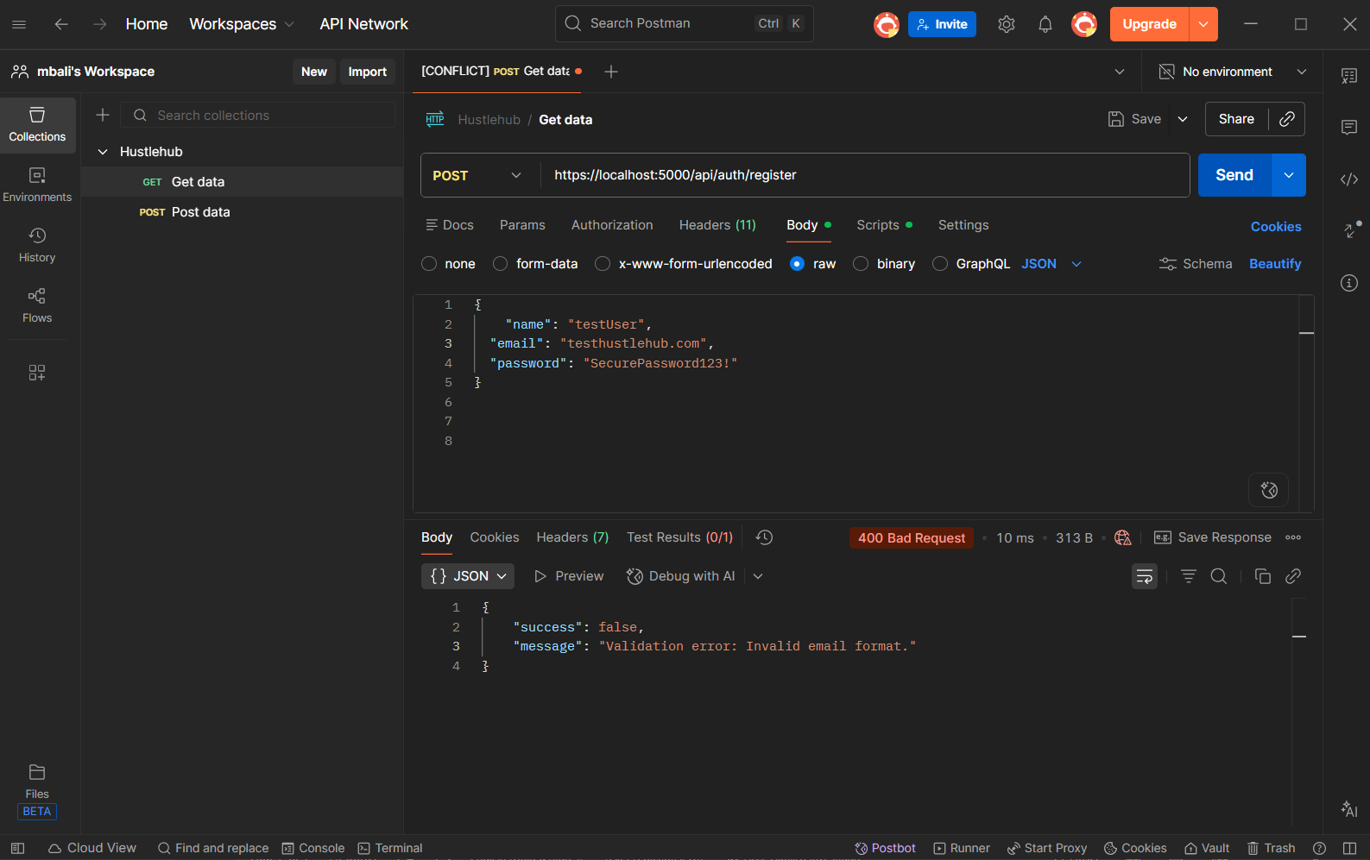

Test 4: Unsuccessful login (Incorrect password):
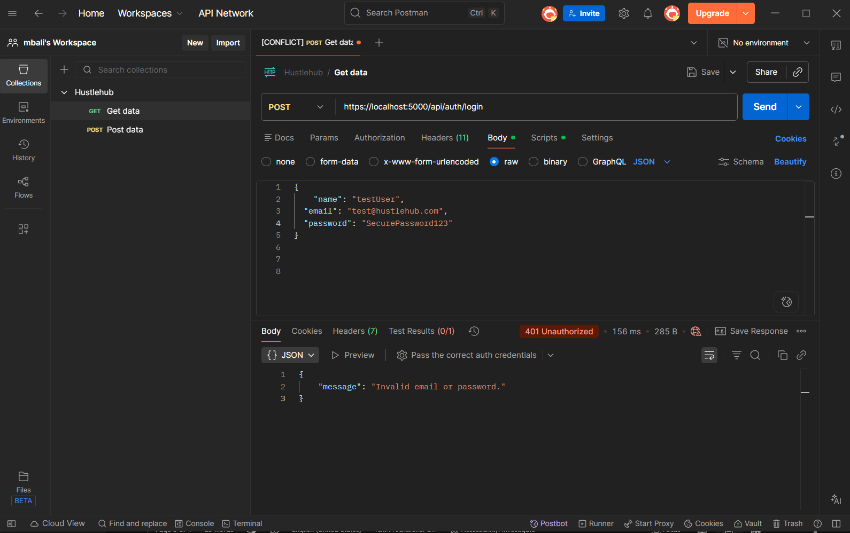
Test 5: Access Protected Route with Token (Success):
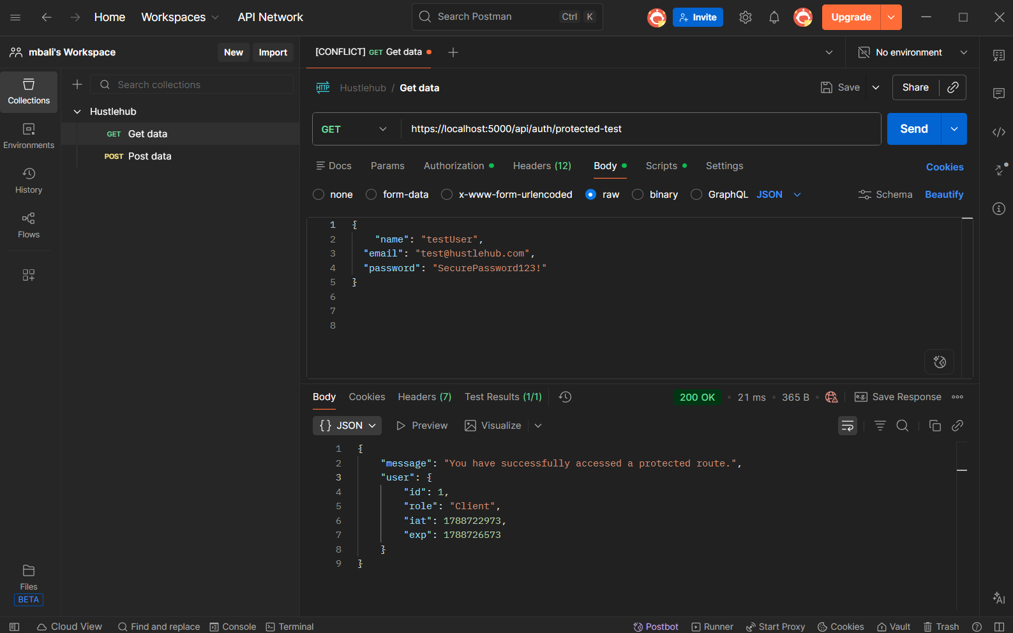

Test 6: Successful login:
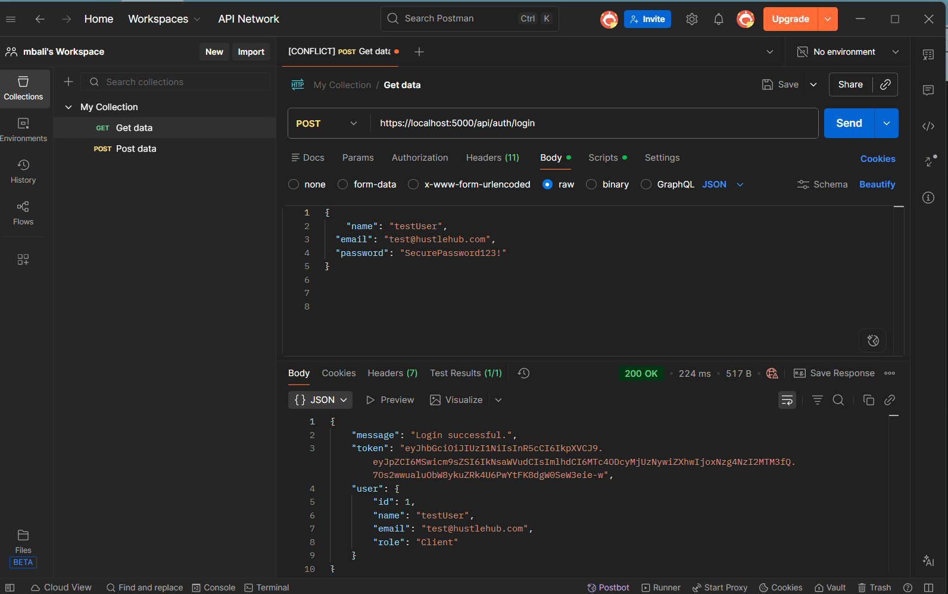

Test 7: Access Protected Route Without Token (Failure):


